**AWS VPC Infrastructure Project Documentation**

**Project Overview**

This project demonstrates the creation of a **highly available, scalable, and secure AWS Virtual Private Cloud (VPC)** architecture. The infrastructure is designed to host web applications across multiple availability zones with automated scaling and secure internet access.

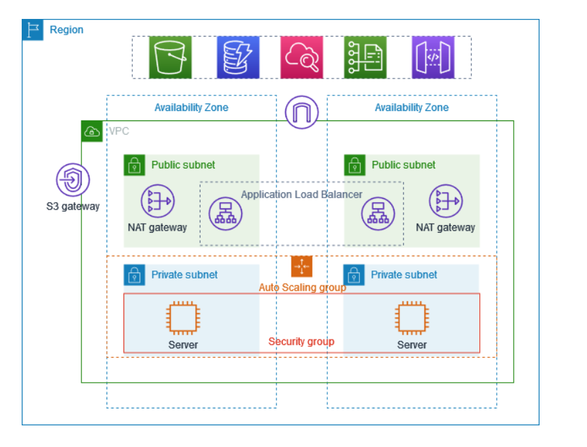

**Architecture Summary**

The infrastructure consists of the following key components:

**VPC & Subnet Design**

* **VPC**: Custom VPC spanning **2 Availability Zones (AZs)** to ensure high availability.
* **Subnets**:
  + **Public Subnets** (1 per AZ): Host NAT Gateways and Application Load Balancer.
  + **Private Subnets** (1 per AZ): Host EC2 instances in an Auto Scaling Group.

**Networking & Routing**

* **Internet Gateway**: Allows outbound internet access via the public subnets.
* **NAT Gateways**: Deployed in public subnets to allow private subnet resources to access the internet without being directly exposed.
* **Route Tables**:
  + Public subnets route to the Internet Gateway.
  + Private subnets route through the NAT Gateways.

**Security & Access Control**

* **Security Groups**:
  + Restrict access to EC2 instances.
  + Allow HTTP/HTTPS traffic to the Application Load Balancer.
* **S3 Gateway Endpoint**: Enables private access to S3 buckets without internet exposure.

**Application Load Balancer & Auto Scaling**

* **Application Load Balancer (ALB)**:
  + Deployed across public subnets.
  + Distributes traffic to EC2 instances in the private subnets.
* **Auto Scaling Group**:
  + Dynamically scales EC2 instances based on demand.
  + Ensures high availability across both Availability Zones.

**Services Integrated**

* **Amazon EC2**: For hosting application servers.
* **Amazon S3**: Accessed privately using VPC S3 Gateway.
* **Amazon CloudWatch** *(optional)*: For monitoring logs and metrics (assumed based on best practices).
* **Elastic Load Balancing (ALB)**: For traffic distribution.
* **Auto Scaling**: For automatic instance scaling.

**Key Features**

* ✅ **Highly Available**: Multi-AZ design ensures redundancy.
* ✅ **Scalable**: Auto Scaling adjusts resources automatically.
* ✅ **Secure**: Private subnets, NAT Gateway, and security groups control access.
* ✅ **Cost-Optimized**: Uses NAT Gateways efficiently and minimizes public exposure.

**Potential Enhancements**

* Add **RDS in private subnets** for database services.
* Implement **CloudWatch Alarms and Logs**.
* Introduce **AWS WAF** and **Shield** for extra protection.
* Use **IAM roles** for EC2 to securely access AWS services.

**Proof attached:**

When load is going through AZ -1

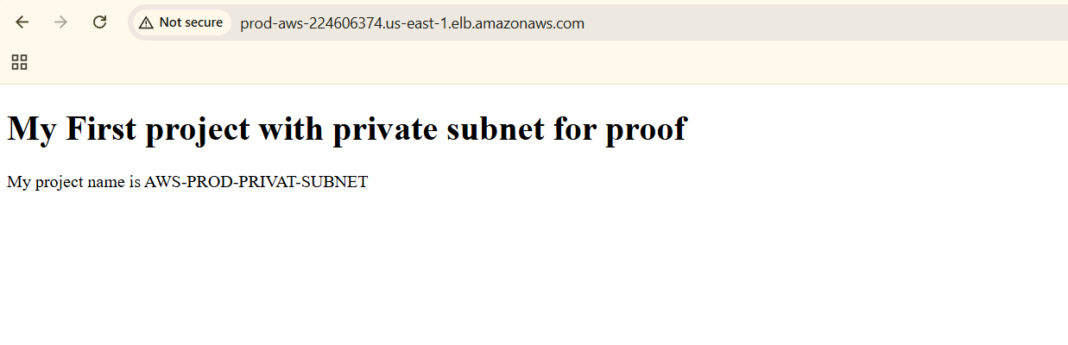

When load is going through AZ-2

